A SPIRITUAL REVOLUTION
The Quest to Experience God

FREE Talk by Giulia Nesi Tetreau, CSB

Do you wonder how to lead a safe and secure life with the threat of pandemic and economic upheaval? An understanding of God as divine Love, present right now, can make a tangible difference in overcoming these issues and finding a way forward.

DAY, MONTH DATE, 2021 at TIME PM
WEBINAR REGISTRATION -
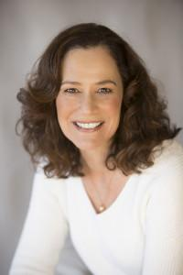
Christian Science practitioner, teacher, and lecturer, Giulia Nesi Tetreau, offers a spiritual perspective on how anyone can experience divine Love as an effective force for good, gaining newfound hope for a better life. She will share tangible examples from her healing practice. Giulia has spent her entire career in the healthcare field, formerly as a psychotherapist and now as a practitioner of Christian Science healing.

