Discover how you can get involved in healing conflicts in our own lives and for the world, from century-old, divisive national conflict to a family fight.

Day, Month Date, at Time
Location name
Location address

International speaker, John Tyler, is a practitioner and teacher of Christian Science healing and a member of the Christian Science Board of Lectureship.

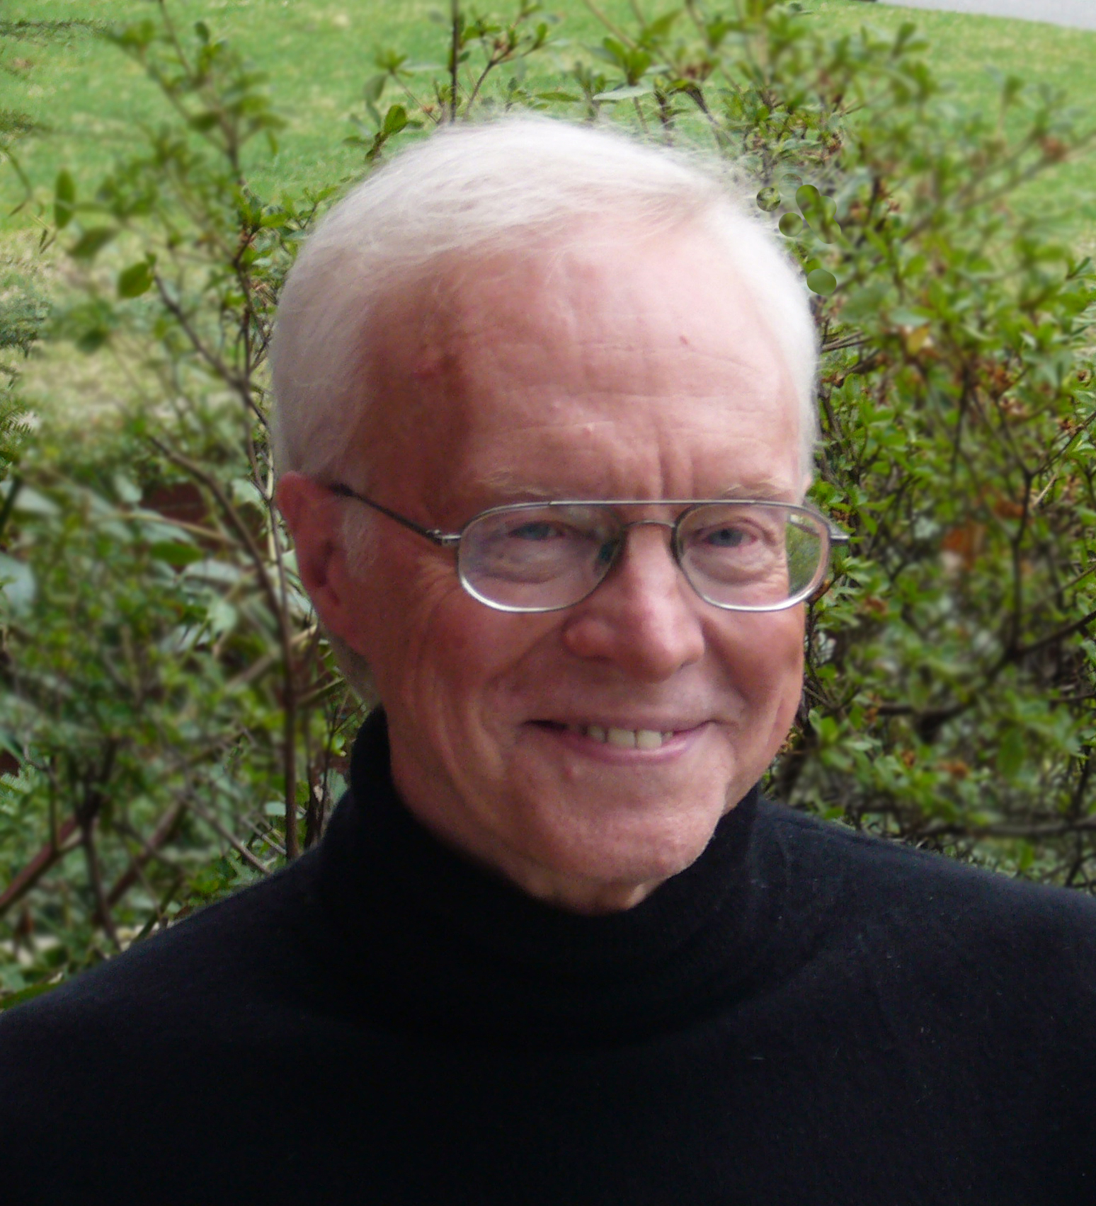
Don’t Sit This One Out!

Explore how prayer can resolve conflict

