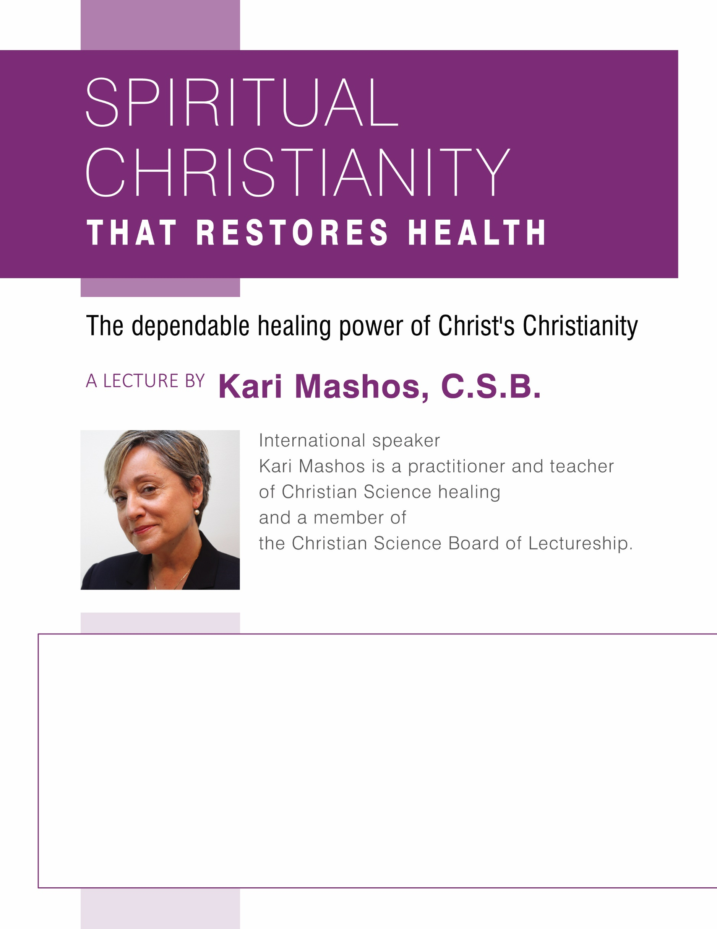

This lecture is sponsored by First Church of Christ, Scientist, Town, Place For more information please call: XXX.XXX.XXXX  
Website address www.cs_church.org

00, Month 00, at 00:00

Location name

Location address