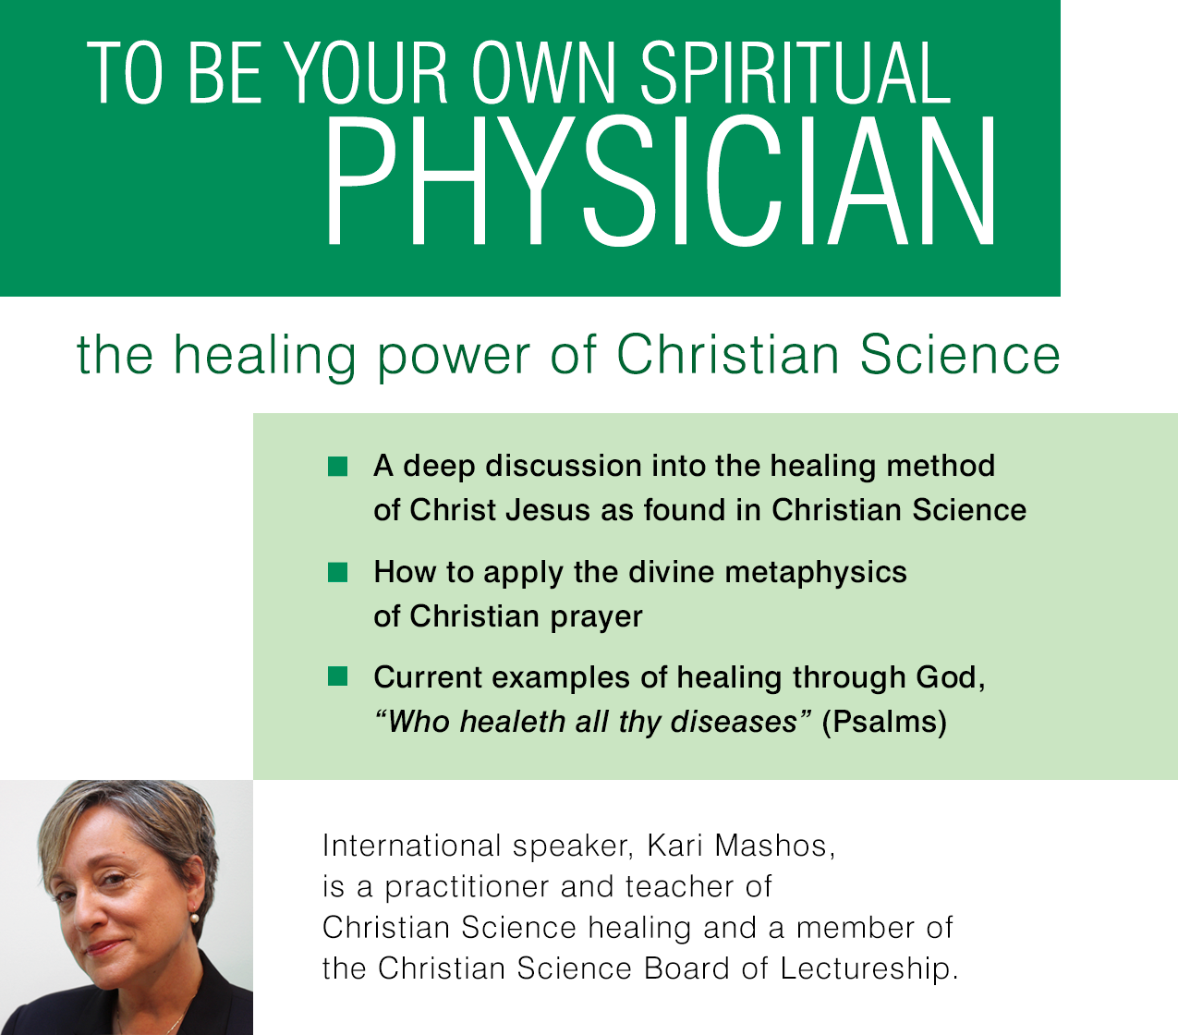

00, Month 00, at 00:00
Location name
Location address
This lecture is sponsored by First Church of Christ, Scientist, Town, Place
For more information please call: XXX.XXX.XXXX
Website address www.cs_church.org

