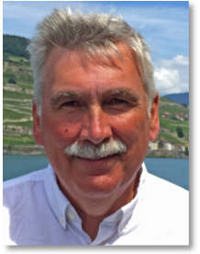
Can’t seem to find enough time?
Discover that …
Time is not a factor in your life
Speaker Dave Hohle, CSB
of Chicago, IL is a member
of the Christian Science Board
of Lectureship
Christian Science Lecture
Day, Month Date
Time

Location Name
Address
City

For more information, www.websiteurl.com
Learn to exercise your God-given freedom from the limitations of time including age, stress, inefficiency, frustration, past mistakes and missed opportunities.

